Azure Identity & Access Management Lab

Bryan Tiffany
4/13/2026
Project Summary
This project demonstrates the implementation of identity and access management using Microsoft Azure and Active Directory. A resource group and virtual machine were deployed, followed by the installation and configuration of Active Directory Domain Services (AD DS). Organizational Units (OUs), users, and security groups were created to simulate a business environment. Additionally, users and groups were managed in Microsoft Entra ID, and role-based access control (RBAC) was implemented to assign permissions at the resource group level.

Active Directory — Initial Setup

Configured Active Directory Domain Services (AD DS)
Description:
Active Directory Domain Services (AD DS) was installed and configured on a Windows Server virtual machine to enable centralized identity management.
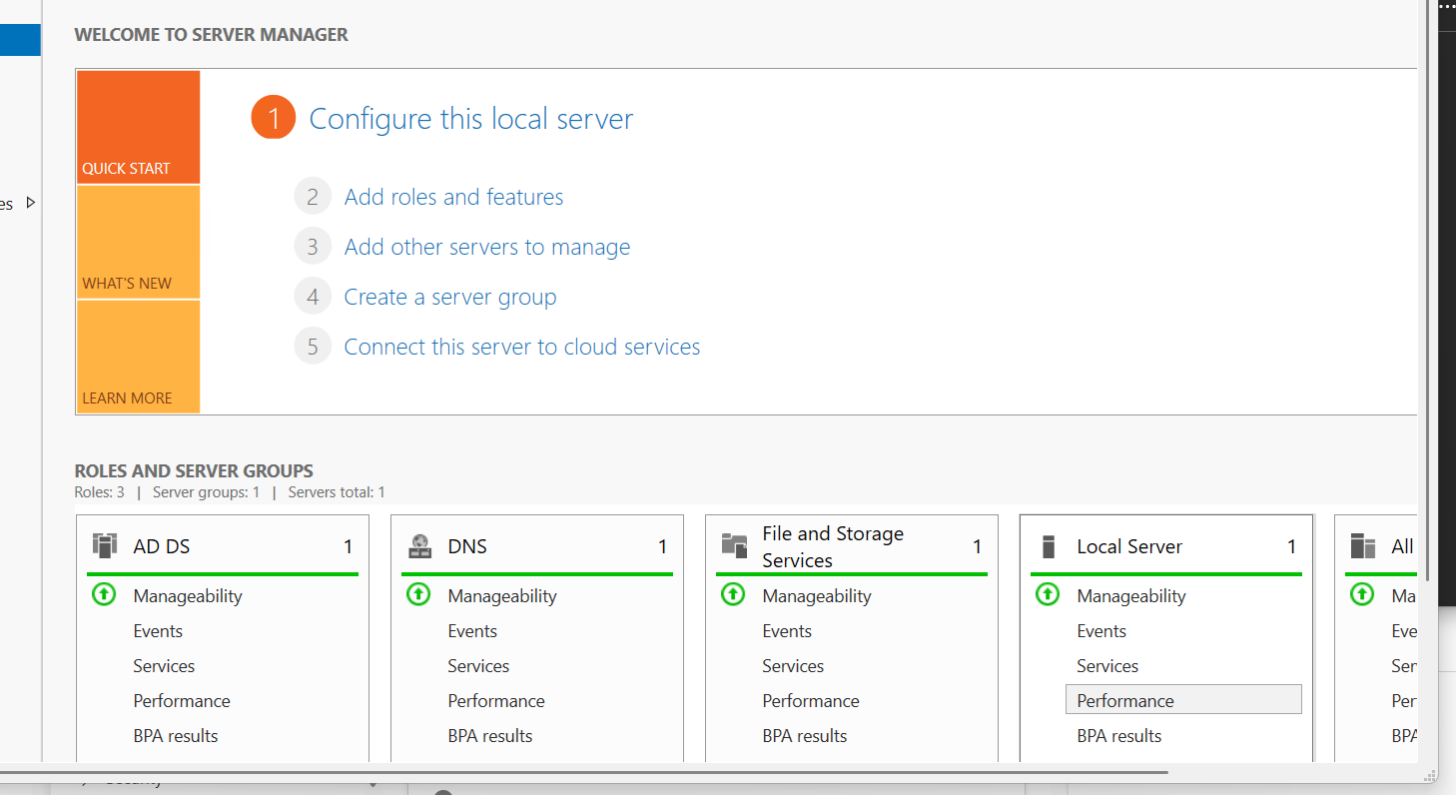

Created HR Organizational Unit
Description:
An HR Organizational Unit (OU) was created in Active Directory, along with a user and security group to represent departmental structure and access control
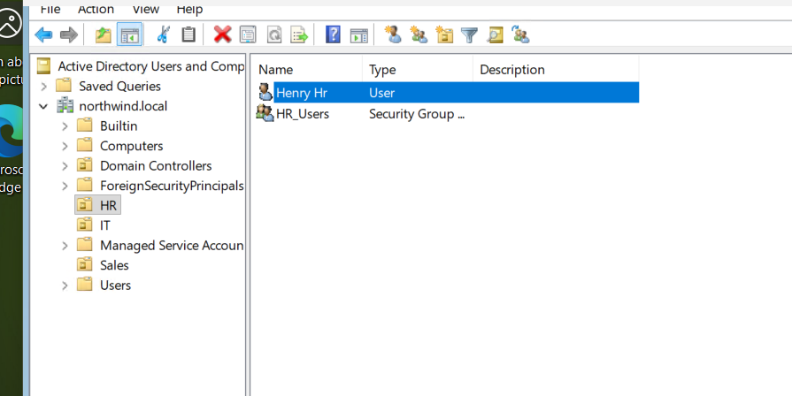

Created IT Organizational Unit
Description:
An IT Organizational Unit (OU) was created with an associated user and security group to organize identities and manage access by department.
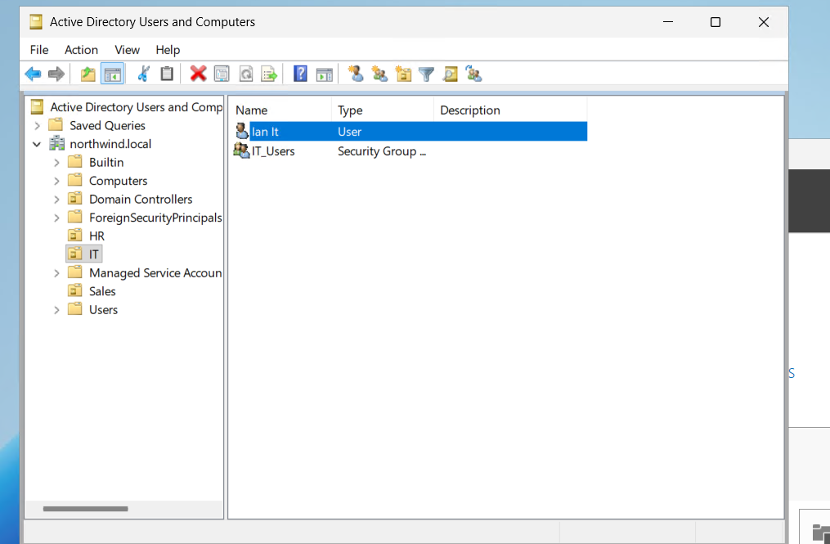

Created Sales Organizational Unit
Description:
A Sales Organizational Unit (OU) was created with a user and security group to demonstrate structured identity organization in Active Directory.

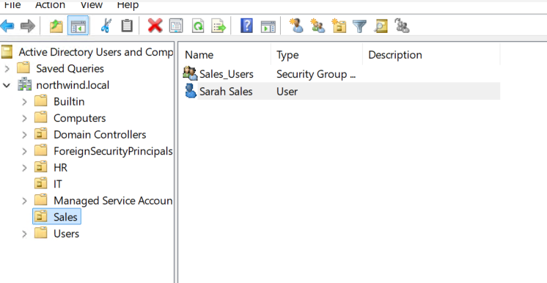
Active Directory Access Explanation
Active Directory is used to manage on-premises identities and organize users into Organizational Units (OUs) based on departments. Security groups are used to control access, allowing administrators to assign permissions to groups rather than individual users.

Entra ID — Initial Setup

Created Azure Resource Group
A resource group named Northwind-RG was created using Azure PowerShell to organize and manage cloud resources.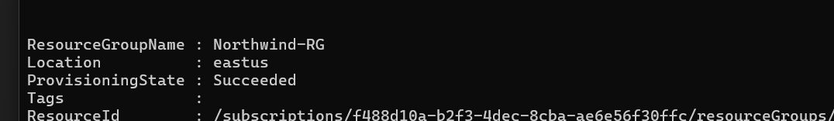

Created Users in Microsoft Entra ID
Description:
User accounts were created in Microsoft Entra ID to represent employees and enable cloud-based identity management.
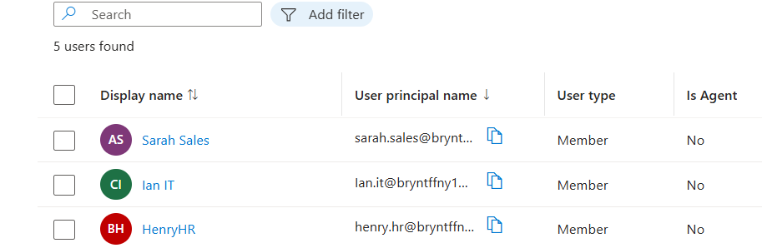

Verified Groups in Azure Using PowerShell
Description:
Departmental groups (Sales, HR, IT) were retrieved using Azure PowerShell to confirm successful group creation.
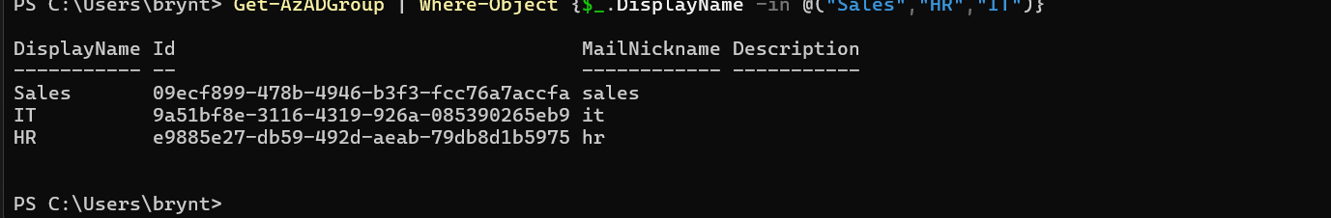

Verified Group Membership in Azure
Description:
Users were added to the All Employees group, and membership was verified using Azure PowerShell to confirm proper group-based access assignment.
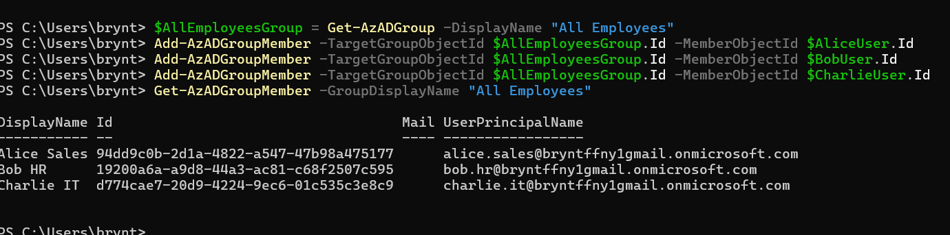

Entra ID Access Explanation
Microsoft Entra ID is used to manage cloud-based identities and access to applications. Users are assigned to groups, which allows permissions to be managed efficiently using group-based access instead of assigning permissions individually.

Identity Summary
Microsoft Entra ID handles cloud-based identity management and access to applications and resources. Active Directory manages on-premises users, organizational structure, and internal access control. Groups are important because they simplify permission management by allowing access to be assigned at the group level rather than individually. To add a new employee, an administrator would create a user account, place the user in the appropriate Organizational Unit (OU), and assign them to the correct group to automatically apply permissions.

Entra ID — After Expansion (Part 2)

How Finance was handled
The Finance department was implemented by creating a dedicated Finance security group in Microsoft Entra ID and a Finance Organizational Unit (OU) with a Finance Users group in Active Directory. Finance users were placed into their respective group and OU, ensuring that access can be assigned at the group level rather than individually. This structure allows for scalable and efficient management as the organization grows. 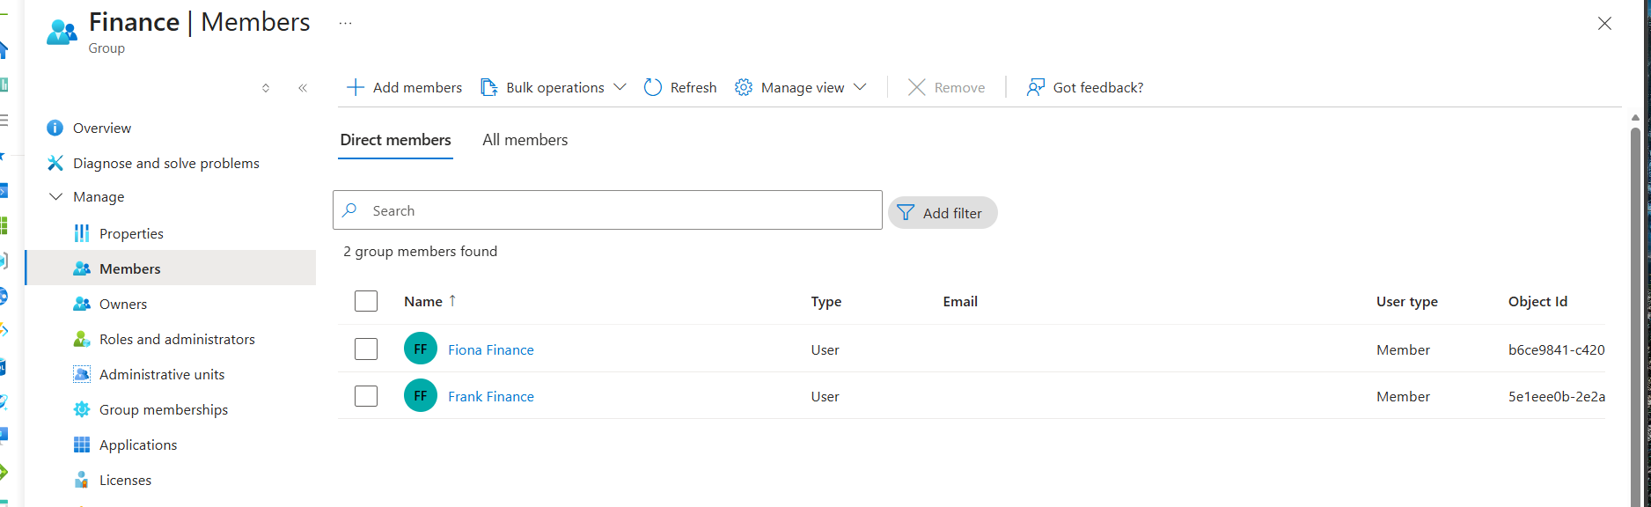
Azure showing Fiona and Frank in the Finance Group.
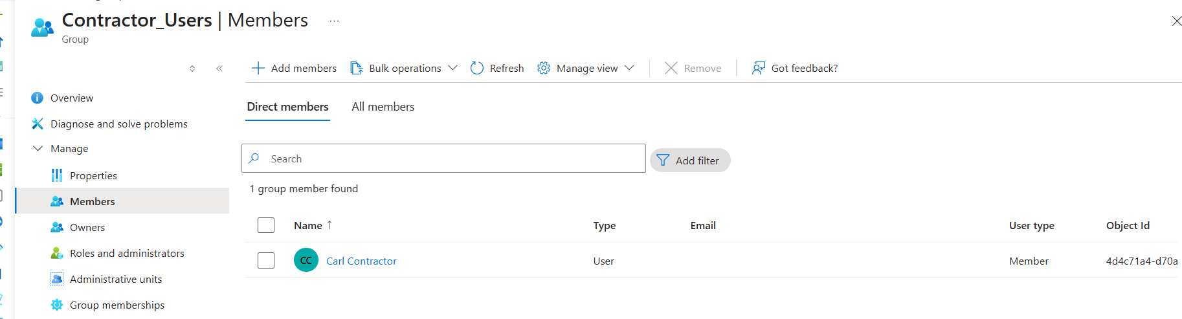
Azure Showing Carl Contractor in the Contractor_Users Group.
RBAC (Bonus / Advanced)

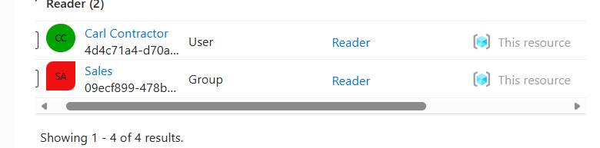
Azure show Carl Contractor only has Reader Access (least privilege).

Active Directory — After Expansion
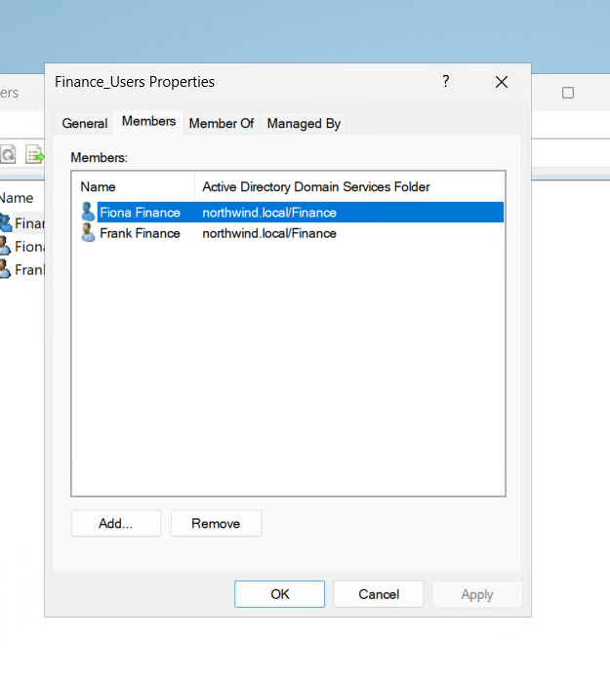
Active Directory showing Fiona and Frank in the Finance Group.
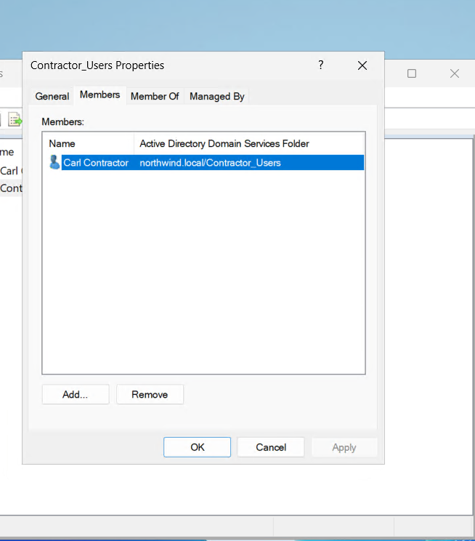
Active Directory showing Carl is in the Contractor_Users Group.

Implementation Summary

How Finance was handled
The Finance department was implemented by creating a dedicated Finance security group in Microsoft Entra ID and a Finance Organizational Unit (OU) with a Finance Users group in Active Directory. Finance users were placed into their respective group and OU, ensuring that access can be assigned at the group level rather than individually. This structure allows for scalable and efficient management as the organization grows.

How the contractor was handled
The contractor account was handled separately by creating a Contractor Users group in both Entra ID and Active Directory. The contractor user, Carl Contractor, was only added to this group and not included in any departmental groups. Additionally, a Reader role was assigned in Azure, ensuring the contractor has read-only access to resources. This follows the principle of least privilege and limits unnecessary access.

Why this structure was chosen
This structure was designed to keep identity management organized, scalable, and secure. By separating users into departments using groups and Organizational Units, administrative tasks become easier to manage. Group-based access control reduces the need to assign permissions individually, minimizes errors, and ensures consistency across the environment. Separating contractors further improves security by restricting their access.

How to provision a new user in the future
To provision a new user, an administrator would create the user account in both Entra ID and Active Directory, place the user in the correct Organizational Unit (OU), and assign them to the appropriate department group. Once added to the group, the user automatically receives the correct permissions based on their role. This process ensures consistency and simplifies onboarding as the organization grows.

Section 4 — What I Built
I built a hybrid identity environment using Microsoft Entra ID and Active Directory to simulate a real-world organization. Departments including Sales, HR, IT, and Finance were created, each with their own users and security groups. Group-based access control was used to manage permissions efficiently, ensuring users receive access based on their department. Both cloud and on-premises identity systems were structured to support scalability and consistent user management.

Section 5 — Ticket Challenge Solution
To support the new Finance department, a Finance Group was created in Entra ID and a Finance Organizational Unit (OU) with a Finance group was created in Active Directory. Two Finance users were added and assigned to the appropriate group.
A contractor account was handled separately by creating a Contractor Group and assigning the contractor user only to that group. Additionally, a Reader role was assigned in Azure to provide read-only access. This ensured limited access and followed the principle of least privilege.
The environment was structured using groups and Organizational Units to keep identity management organized, scalable, and secure.

Section 6 — What This Demonstrates
This project demonstrates key identity and access management concepts including user provisioning, group-based access control, and hybrid identity integration. It shows the ability to manage both cloud and on-premises identities, apply least privilege principles, and organize users in a scalable way. The project also reflects the ability to execute both guided tasks and independent problem-solving through a ticket-based challenge scenario.

